

Practices for Secure Software Report

Table of Contents
Document Revision History 3
Client 3
Instructions 3
Developer 4
1. Algorithm Cipher 4
2. Certificate Generation 4
3. Deploy Cipher 4
4. Secure Communications 4
5. Secondary Testing 4
6. Functional Testing 4
7. Summary 4
8. Industry Standard Best Practices 4

Document Revision History

Version | Date | Author | Comments
1.0 | February 22, 2026 | Thomas Archer | Initial submission

Client



Instructions

Submit this completed practices for secure software report. Replace the bracketed text with the relevant information. You must document your process for writing secure communications and refactoring code that complies with software security testing protocols.

- Respond to the steps outlined below and include your findings.
- Respond using your own words. You may also choose to include images or supporting materials. If you include them, make certain to insert them in all the relevant locations in the document.
- Refer to the Project Two Guidelines and Rubric for more detailed instructions about each section of the template.

Developer
Thomas Archer

Algorithm Cipher

For Artemis Financial's data verification needs, I recommend SHA-256 (Secure Hash Algorithm 256-bit) as the cryptographic hash algorithm. SHA-256 is a member of the SHA-2 family, first published by the National Institute of Standards and Technology (NIST) in 2001 as part of the Secure Hash Standard (FIPS PUB 180-2) and later updated in FIPS PUB 180-4 (National Institute of Standards and Technology [NIST], 2015a). It produces a fixed 256-bit (32-byte) hash value regardless of input size, making it ideal for verifying data integrity. The algorithm processes input data in 512-bit blocks through 64 rounds of compression, producing a unique hexadecimal output. Any change to the input, no matter how small, results in a completely different hash. This property is known as the avalanche effect.

SHA-256 is a one-way hash function, meaning the original data cannot be recovered from the hash output. This distinguishes it from encryption, which is reversible. While symmetric encryption algorithms like AES use a single shared key for both encryption and decryption, and asymmetric algorithms like RSA use a public/private key pair, hash functions like SHA-256 do not use keys at all. Instead, they produce a fixed-length digest used for verification purposes. For securing the HTTPS communication layer in this project, RSA 2048-bit asymmetric encryption is used for the SSL/TLS certificate, which employs random number generation during the key pair creation process to ensure uniqueness.

The history of cryptographic hash algorithms reflects a progression toward stronger security. MD5 (128-bit) was widely used in the 1990s but is now considered broken due to demonstrated collision attacks (Wang & Yu, 2005). SHA-1 (160-bit) replaced MD5 but was deprecated by NIST in 2011 and disallowed for digital signatures at the end of 2013 (NIST, 2024). SHA-2, which includes SHA-256, remains the current industry standard and is approved by NIST for federal use. In August 2015, NIST published FIPS 202, establishing SHA-3 as an additional standard based on the Keccak algorithm selected through an open public competition (NIST, 2015b). SHA-3 serves as an alternative to SHA-2 rather than a replacement, as SHA-2 continues to be secure and widely deployed (NIST, 2015b). For Artemis Financial's requirements, SHA-256 provides a strong balance of security and performance and is widely supported across Java's standard cryptographic libraries.

Certificate Generation
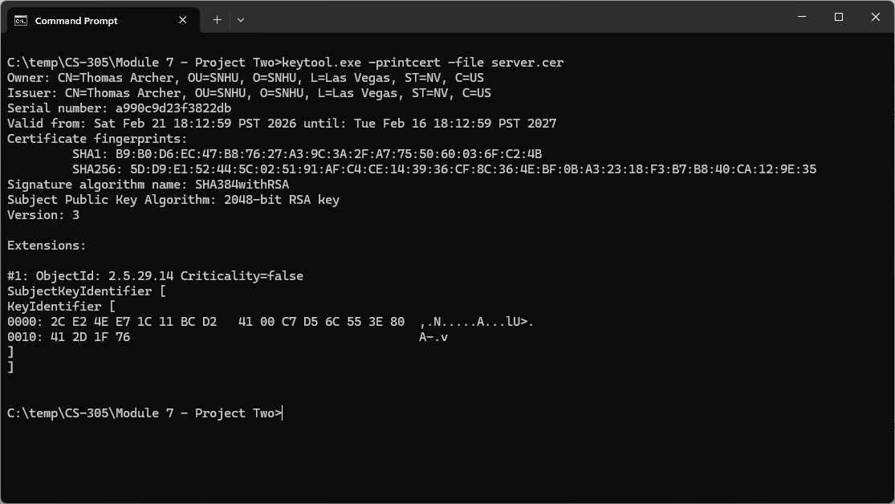

Deploy Cipher
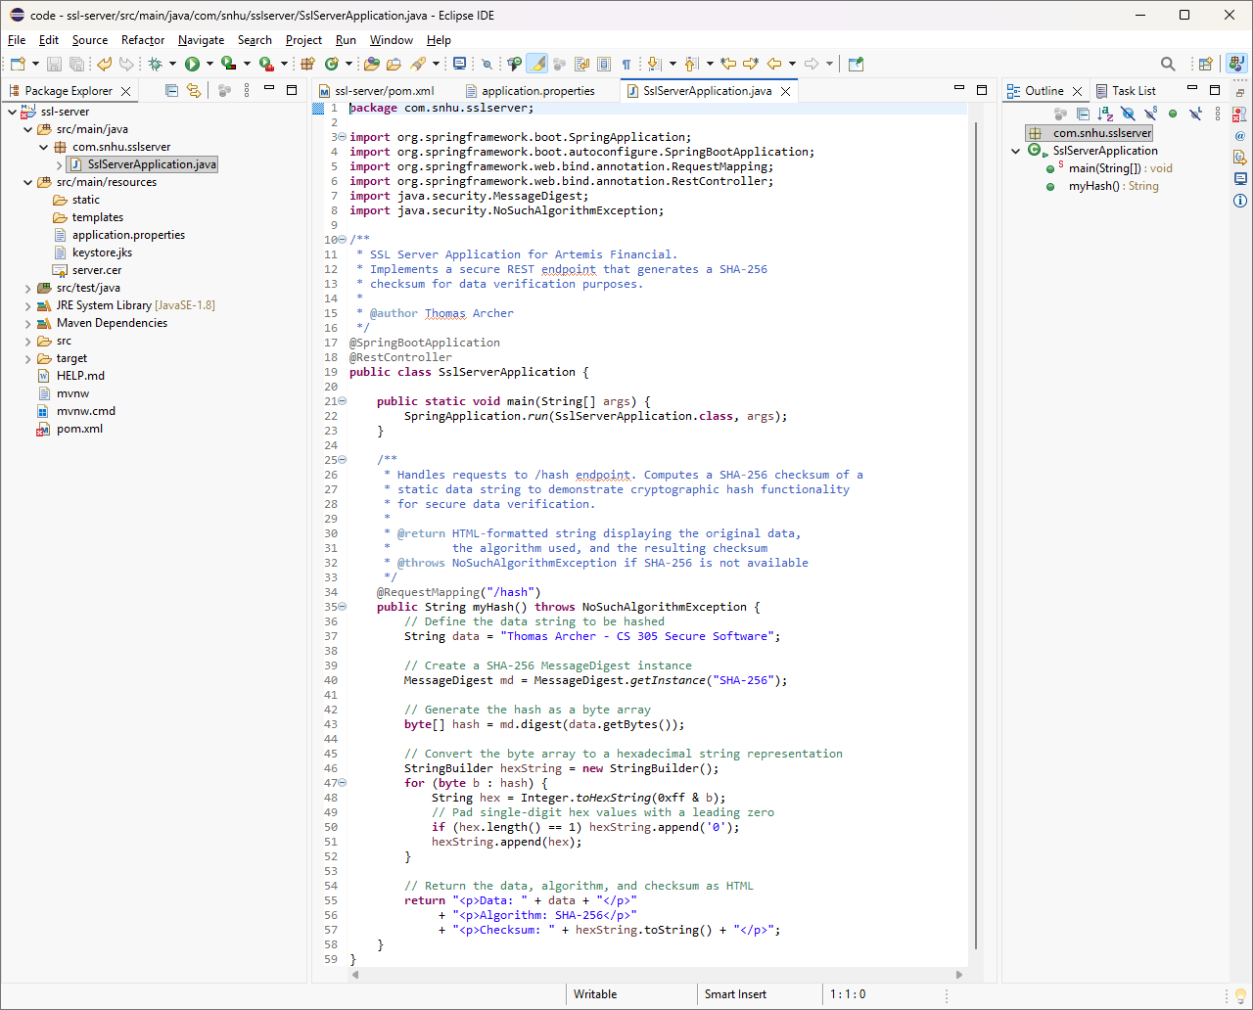

Secure Communications
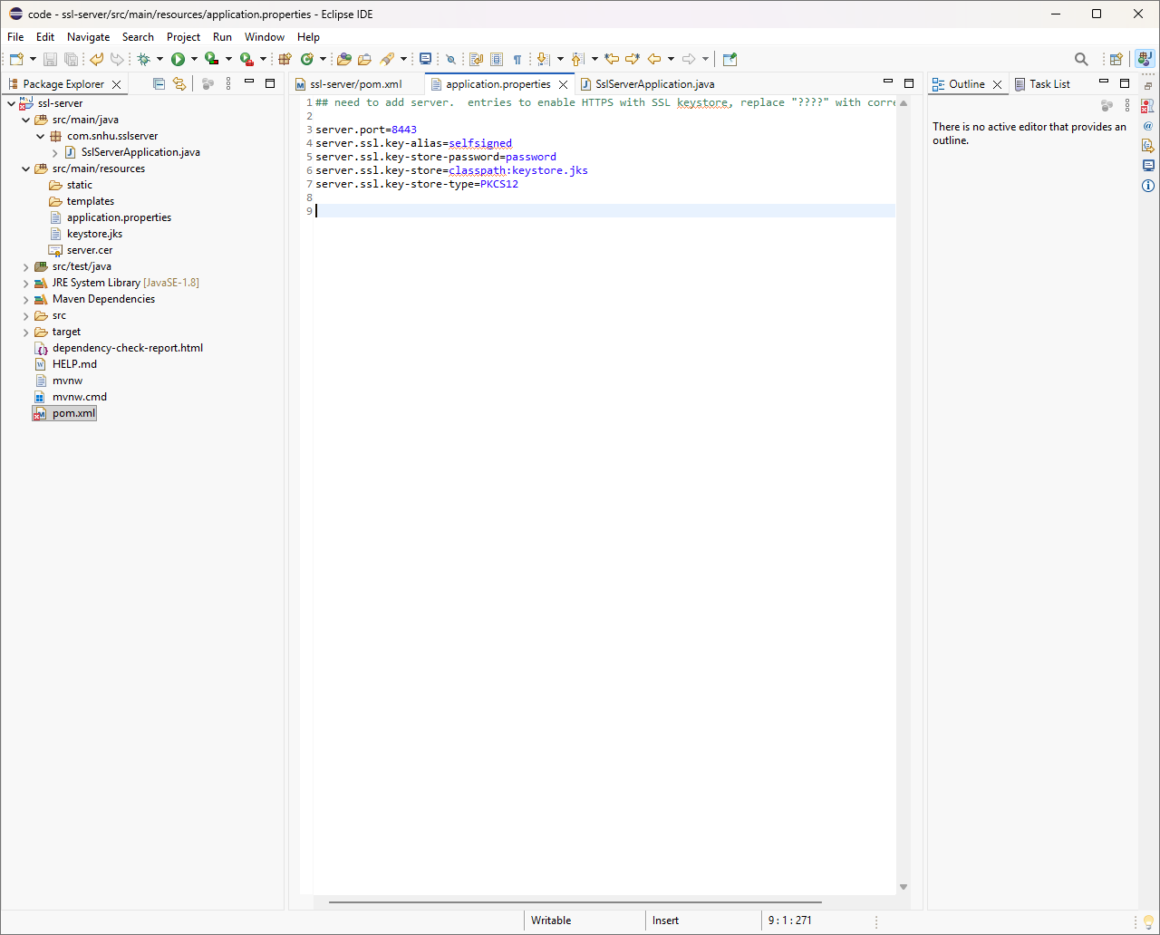

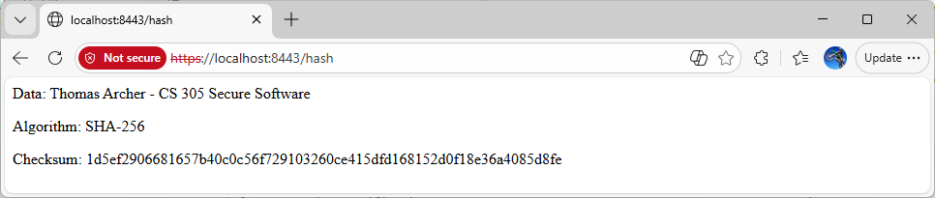

Secondary Testing

The dependency check was run before and after refactoring. The after report confirmed no new vulnerabilities were introduced by the refactored code.

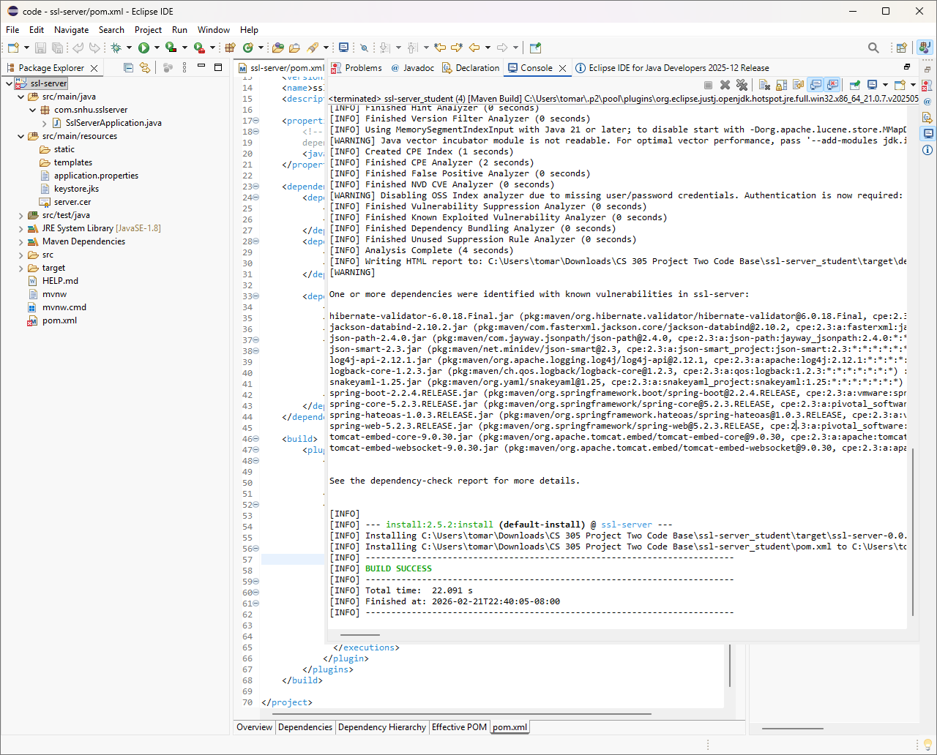
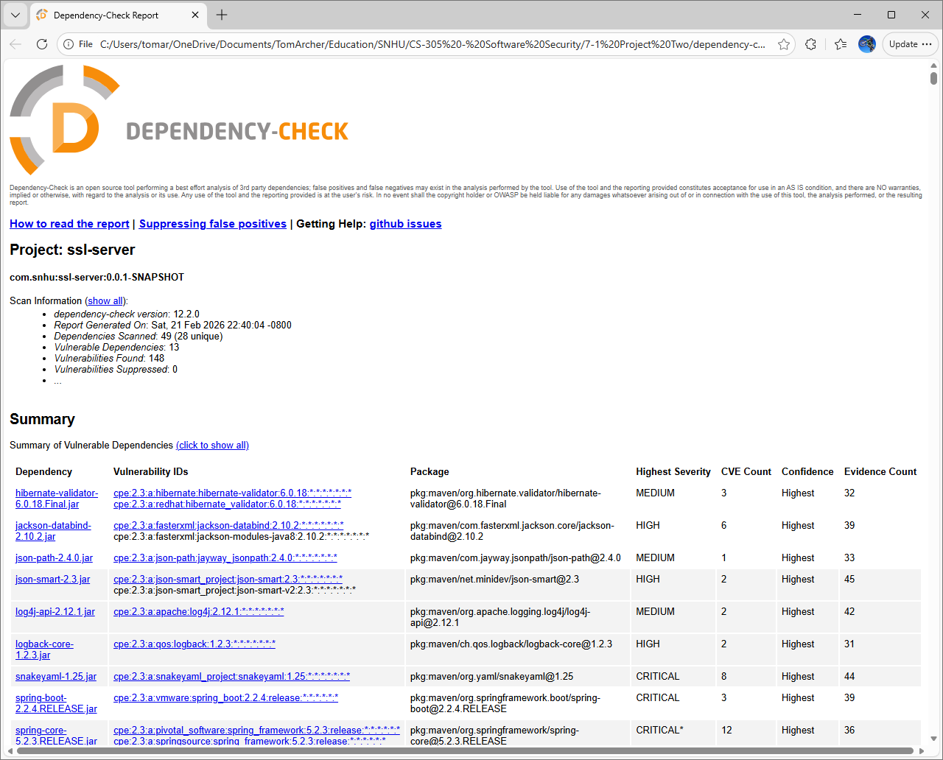

Functional Testing

A manual code review of the original application identified several security vulnerabilities prior to refactoring.

First, the application had no data verification mechanism. The SslServerApplication.java file contained only the default Spring Boot main method with a FIXME comment indicating that a checksum route needed to be added. Without this functionality, there was no way to verify the integrity of data transmitted through the application.

Second, the application.properties file contained placeholder values (????) for all SSL/TLS configuration properties. This meant the application was configured to run on port 8443 but had no functioning HTTPS implementation, leaving all client-server communications unencrypted and vulnerable to interception.

Third, the pom.xml specified a Java version of 1.8 and included an outdated version of the OWASP dependency-check plugin (5.3.0). The plugin version was updated to 12.2.0 to ensure the most current vulnerability database was used during static testing, and the Java version was updated to 11 to meet the minimum requirement of the updated plugin.

Fourth, the application relied on Spring Boot 2.2.4.RELEASE and its associated dependencies, many of which contain known vulnerabilities including critical CVEs in Spring Framework, Apache Tomcat, and SnakeYAML. While upgrading these dependencies was outside the scope of this assignment, the dependency-check reports document these vulnerabilities for future remediation.

After refactoring, the application was retested and confirmed to compile and run without syntactical or logical errors. The refactored code introduced no new security vulnerabilities, as verified by the secondary dependency check.

Summary

The refactoring of Artemis Financial's software application addressed multiple areas of the Vulnerability Assessment Process Flow Diagram. The primary areas addressed were Cryptography, Client/Server, Code Quality, and APIs.

In the area of Cryptography, I implemented a SHA-256 cryptographic hash algorithm to provide data verification functionality. SHA-256 is a NIST-approved algorithm specified in FIPS PUB 180-4 that produces a 256-bit hash digest, enabling Artemis Financial to verify data integrity during communications (NIST, 2015a). The implementation uses Java's built-in MessageDigest class, which provides a secure and well-tested cryptographic library rather than a custom implementation.

In the area of Client/Server, I converted the application from HTTP to HTTPS by generating a self-signed SSL/TLS certificate using Java's keytool utility with RSA 2048-bit encryption and configuring the application to use port 8443 with the PKCS12 keystore. This ensures that all communication between the client browser and the server is encrypted, protecting Artemis Financial's sensitive financial data in transit.

In the area of APIs, I created a secure REST endpoint (/hash) using Spring Boot's @RestController and @RequestMapping annotations. This endpoint serves as the checksum verification interface, returning the original data string, the algorithm used, and the resulting hash value. The endpoint operates exclusively over HTTPS, ensuring secure API interactions.

In the area of Code Quality, I ran the OWASP dependency-check tool both before and after refactoring to verify that no new vulnerabilities were introduced by the code changes. The secondary dependency check confirmed that the vulnerability profile remained unchanged, with the same 13 vulnerable dependencies and 148 CVEs present in both the before and after reports. All identified vulnerabilities are attributable to the pre-existing third-party dependencies in the original code base, not to the refactored code.

The layered security approach, which combined cryptographic hashing for data verification, SSL/TLS encryption for secure communications, and static analysis testing for vulnerability detection, provides Artemis Financial with multiple levels of protection for its client data and financial information.

Industry Standard Best Practices

Several industry standard best practices were applied throughout the refactoring of Artemis Financial's application.

First, I used a NIST-approved cryptographic algorithm (SHA-256) rather than a deprecated algorithm such as MD5 or SHA-1, aligning with current federal standards for secure hashing as specified in FIPS PUB 180-4 (NIST, 2015a).

Second, I relied on Java's built-in java.security.MessageDigest library for the hash implementation rather than writing custom cryptographic code, following the well-established principle of using vetted, widely tested cryptographic libraries rather than custom implementations.

Third, I used RSA 2048-bit key generation for the SSL/TLS certificate, which meets current NIST recommendations for minimum key lengths (NIST, 2024).

Fourth, I used the OWASP dependency-check tool to perform static analysis testing on all third-party dependencies, which aligns with the OWASP Top Ten recommendation to identify components with known vulnerabilities (OWASP Foundation, 2021). Running this check both before and after refactoring ensured that no new vulnerabilities were introduced during the development process.

Applying these best practices directly supports Artemis Financial's overall well-being as a company. As a financial consulting firm handling sensitive client data including savings, retirement, investments, and insurance information, a security breach could result in regulatory penalties, loss of client trust, and significant financial liability. By implementing encryption in transit via HTTPS, verifying data integrity through cryptographic hashing, and continuously monitoring third-party dependencies for known vulnerabilities, Artemis Financial demonstrates due diligence in protecting its clients' data. This proactive approach to security reduces the company's risk exposure and supports compliance with industry regulations governing financial data protection.

References
National Institute of Standards and Technology. (2015a). Secure hash standard (SHS) (FIPS PUB 180-4). U.S. Department of Commerce. https://csrc.nist.gov/pubs/fips/180-4/upd1/final
National Institute of Standards and Technology. (2015b, August 5). NIST releases SHA-3 cryptographic hash standard [Press release]. https://www.nist.gov/news-events/news/2015/08/nist-releases-sha-3-cryptographic-hash-standard
National Institute of Standards and Technology. (2024, September 9). Hash functions. Computer Security Resource Center. https://csrc.nist.gov/projects/hash-functions
OWASP Foundation. (2021). OWASP Top Ten. https://owasp.org/www-project-top-ten/
Wang, X., & Yu, H. (2005). How to break MD5 and other hash functions. In R. Cramer (Ed.), Advances in Cryptology – EUROCRYPT 2005 (Vol. 3494, pp. 19–35). Springer. https://doi.org/10.1007/11426639_2

